1. Giao diện phiếu dịch vụ

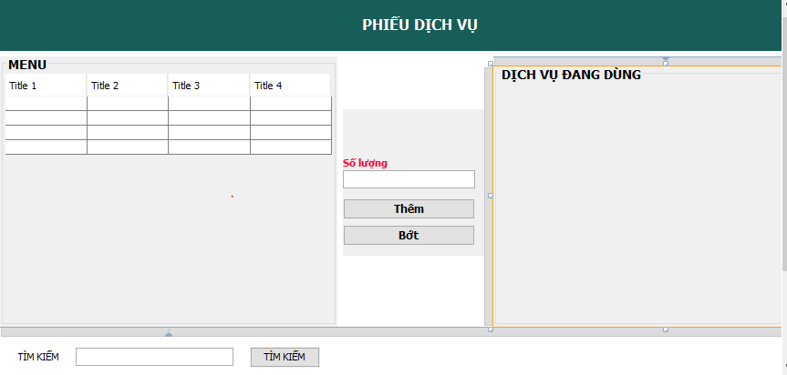

|  |  |  |
| --- | --- | --- |
| Stt | Tên | Kiểu |
| 1 | btn_Bot | JButton |
| 2 | btn_Them | JButton |
| 3 | btn_TimKem | JButton |
| 4 | Btn_Xong | JButton |
| 5 | jLabel1 | JLabel |
| 6 | jPanel1 | JPanel |
| 7 | jScrollPane1 | JScrollPane |
| 8 | *jScrollPane2* | JScrollPane |
| 9 | *lb_SoLuong* | JLabel |
| 10 | *lb_TenDV* | JLabel |
| 11 | *lb_Tien* | JLabel |
| 12 | *lb_TimKiem* | JLabel |
| 13 | *lb_TongTien* | JLabel |
| 14 | *panel_Buttons* | JPabel |
| 15 | panel_Contain | JPabel |
| 16 | panel_TimKiem | JPabel |
| 17 | panel_Title | JPabel |
| 18 | panel_bg | JPabel |
| 19 | table_Menu | JTable |
| 20 | table_Order | JTable |
| 21 | txt_SoLuong | JTextField |
| 22 | txt_TimKiem | JTextField |

1. **Giao diện login tài khoản**

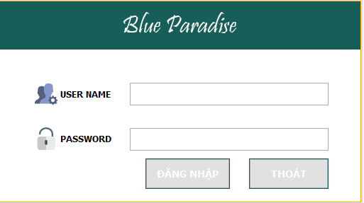

|  |  |  |
| --- | --- | --- |
| stt | tên | Loại |
| 1 | btn_DangNhap | JButton |
| 2 | btn_Thoat | JButton |
| 3 | image_Logo | JLabel |
| 4 | image_Password | JLabel |
| 5 | image_Username | JLabel |
| 6 | panel_Title | JPanel |
| 7 | panel_bg | JPanel |
| 8 | pwd_Password | JPasswordField |
| 9 | txt_UserName | JTextField |

1. Giao diện trả phòng

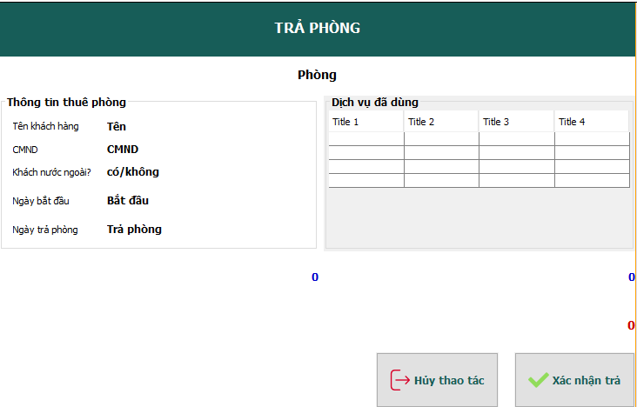

|  |  |  |
| --- | --- | --- |
| stt | Tên | Loại |
| 1 | btn_Huy | JButton |
| 2 | btn_XacNhan | JButton |
| 3 | jLabel1 | JLabel |
| 4 | jLabel2 | JLabel |
| 5 | jLabel3 | JLabel |
| 6 | jLabel4 | JLabel |
| 7 | jLabel5 | JLabel |
| 8 | jScrollPane1 | JScrollPane |
| 9 | lb_CMND | JLabel |
| 10 | lb_KhachNuocNgoai | JLabel |
| 11 | lb_NgayBD | JLabel |
| 12 | lb_NgayKT | JLabel |
| 13 | lb_TenKH | JLabel |
| 14 | lb_TenPhong | JLabel |
| 15 | lb_TienDichVu | JLabel |
| 16 | lb_TienThue | JLabel |
| 17 | lb_Title | JLabel |
| 18 | lb_TongTien | JLabel |
| 19 | panel_Title | JPanel |
| 20 | panel_bg | JPanel |
| 21 | table_Order | JTable |

1. Giao diện trả phòng

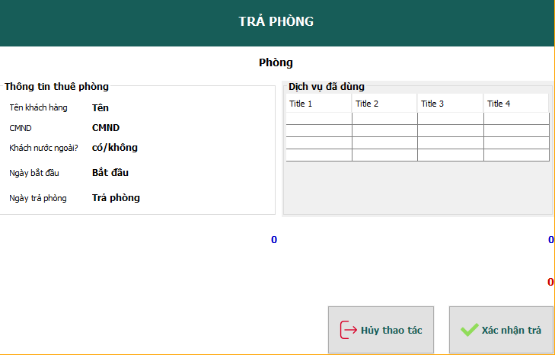

|  |  |  |
| --- | --- | --- |
| stt | Tên | Loại |
|  | btn_Huy | JButton |
|  | btn_XacNhan | JButton |
|  | jLabel11, jLabel12, jLabel13, jLabel14, jLabel15 | JLabel |
|  | jScrollPane1 | JScrollPane |
|  | lb_CMND | JLabel |
|  | lb_KhachNuocNgoai | JLabel |
|  | lb_NgayBD | JLabel |
|  | lb_NgayKT | JLabel |
|  | lb_TenKH | JLabel |
|  | lb_TenPhong | JLabel |
|  | lb_TienDichVu | JLabel |
|  | lb_TienThue | JLabel |
|  | lb_Title | JLabel |
|  | lb_TongTien | JLabel |
|  | panel_Content | JPanel |
|  | panel_Footer | JPanel |
|  | panel_ThongTinThue | JPanel |
|  | panel_bg | JPanel |
|  | table_Order | JPanel |

1. Giao diện quản lí dịch vụ

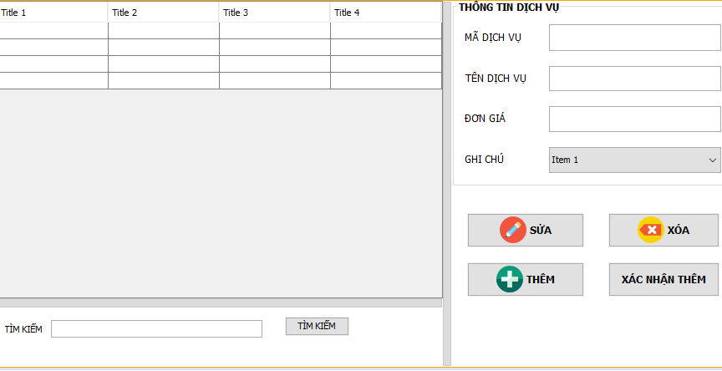

|  |  |  |
| --- | --- | --- |
| stt | Tên | Loại |
|  | btn_Sua | JButton |
|  | btn_Them | JButton |
|  | btn_TimKiem | JButton |
|  | btn_XacNhan | JButton |
|  | btn_Xoa | JButton |
|  | cbb_GhiChu | JComboBox<String> |
|  | jScrollPane2 | JScrollPane |
|  | lb_DonGia | JLabel |
|  | lb_GhiChu | JLabel |
|  | lb_MaDV | JLabel |
|  | lb_TenDV | JLabel |
|  | lb_timkiem | JPanel |
|  | panel_Buttons | JPanel |
|  | panel_Control | JPanel |
|  | panel_ThongTin | JPanel |
|  | panel_TimKiem | JPanel |
|  | table_DSDichVu | JTable |
|  | txt_GiaDV | JTextField |
|  | txt_MaDV | JTextField |
|  | txt_TenDV | JTextField |
|  | txt_TimKiem | JTextField |

1. Giao diện quản lí khách hàng

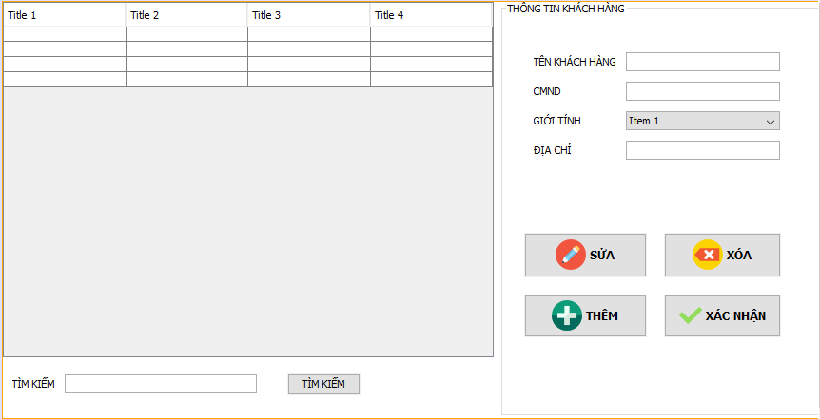

|  |  |  |
| --- | --- | --- |
| stt | Tên | Loại |
|  | btn_Sua | JButton |
|  | btn_Them | JButton |
|  | btn_TimKiem | JButton |
|  | btn_XacNhan | JButton |
|  | btn_Xoa | JButton |
|  | cbb_GioiTinh | JComboBox<String> |
|  | jScrollPane1 | JScrollPane |
|  | lb_DiaChi | JLabel |
|  | lb_GioiTinh | JLabel |
|  | lb_TenKH | JLabel |
|  | lb_TimKiem | JLabel |
|  | panel_ThongTin | JPabel |
|  | panel_TimKiem | JPanel |
|  | panel_bg | JPanel |
|  | table_DSKhachHang | JTable |
|  | txt_CMND | JTextField |
|  | txt_DiaChi | JTextField |
|  | txt_TenKH | JTextField |
|  | txt_TimKiem | JTextField |

1. Giao diện quản lí loại phòng

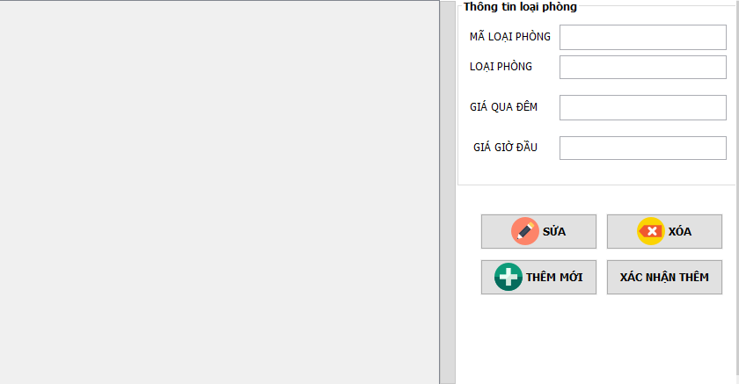

|  |  |  |
| --- | --- | --- |
| stt | Tên | Loại |
|  | btn_Sua | JButton |
|  | btn_Them | JButton |
|  | btn_XacNhanThem | JButton |
|  | btn_Xoa | JButton |
|  | jPanel1 | JPanel |
|  | jPanel2 | JPanel |
|  | jScrollPane1 | JScrollPane |
|  | lb_GiaGioDau | JLabel |
|  | lb_GiaQuaDem | JLabel |
|  | lb_MaLoaiP | JLabel |
|  | lb_TenLoai | JLabel |
|  | panel_Buttons | JPanel |
|  | table_DSLoaiPhong | JTable |
|  | txt_GiaGioDau | JTextField |
|  | txt_GiaQuaDem | JTextField |
|  | txt_MaLoaiP | JTextField |
|  | txt_TenLoaiP | JTextField |

1. Giao diện quản lí nhân viên

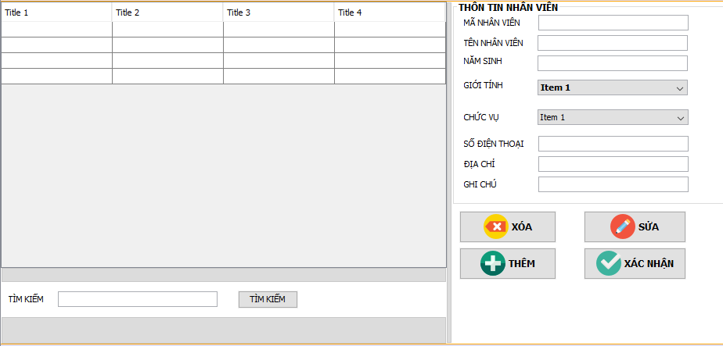

|  |  |  |
| --- | --- | --- |
| sst | Tên | Loại |
|  | btn_Sua | JButton |
|  | btn_Them | JButton |
|  | btn_TimKiem | JButton |
|  | btn_XacNhan | JButton |
|  | btn_Xoa | JButton |
|  | cbb_ChucVu | JComboBox<String> |
|  | cbb_GioiTinh | JComboBox<String> |
|  | jScrollPane1 | JScrollPane |
|  | lb_ChucVu | JLabel |
|  | lb_DiaChi | JLabel |
|  | lb_GhiChu | JLabel |
|  | lb_GioiTinh | JLabel |
|  | lb_MaNV | JLabel |
|  | lb_NamSinh | JLabel |
|  | lb_SDT | JLabel |
|  | lb_TenNV | JLabel |
|  | lb_TimKiem | JLabel |
|  | panel_Buttons | JPanel |
|  | panel_Control | JPanel |
|  | panel_ThongTin | JPanel |
|  | panel_TimKiem | JPanel |
|  | table_DSNhanVien | JTable |
|  | txt_DiaChi | JTextField |
|  | txt_GhiChu | JTextField |
|  | txt_MaNV | JTextField |
|  | txt_NamSinh | JTextField |
|  | txt_SDT | JTextField |
|  | txt_TenNV | JTextField |
|  | txt_TimKiem | JTextField |

1. Giao diện quản lí phòng

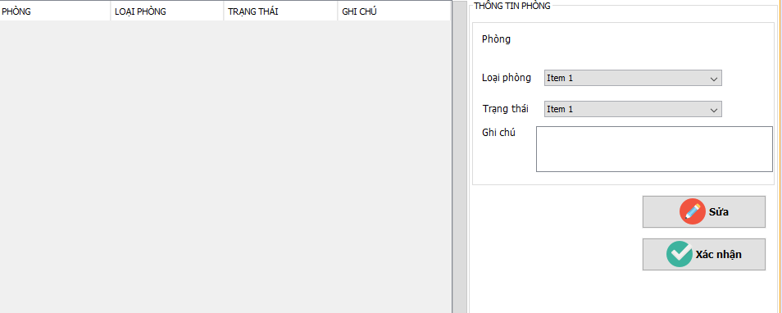

|  |  |  |
| --- | --- | --- |
| stt | Tên | Loại |
|  | btn_Sua | JButton |
|  | btn_XacNhan | JButton |
|  | cbb_LoaiPhong | JComboBox<String> |
|  | cbb_TrangThai | JComboBox<String> |
|  | jPanel1 | JPanel |
|  | jScrollPane1 | JScrollPane |
|  | jScrollPane2 | JScrollPane |
|  | lb_GhiChu | JLabel |
|  | lb_Loai | JLabel |
|  | lb_LoaiPhong | JLabel |
|  | lb_Phong | JLabel |
|  | lb_Ten | JLabel |
|  | lb_TinhTrang | JLabel |
|  | lb_TrangThai | JLabel |
|  | panel_ThongTin | JPanel |
|  | panel_bg | JPanel |
|  | table_DSPhong | JTable |
|  | txtA_GhiChu | JTextArea |

1. Giao diện quản lí

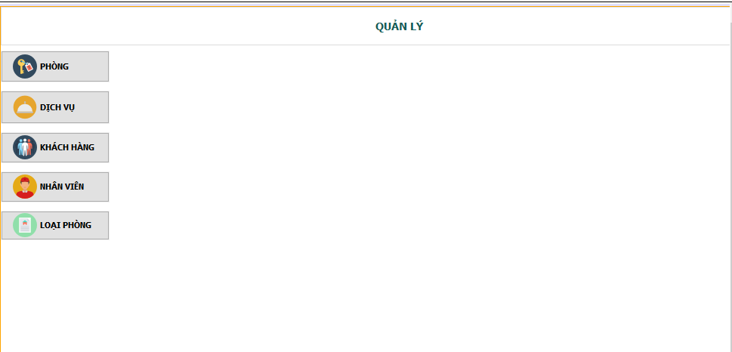

|  |  |  |
| --- | --- | --- |
| stt | Tên | Loại |
|  | btn_QLDichVu | JButton |
|  | btn_QLKhachHang | JButton |
|  | btn_QLLoaiPhong | JButton |
|  | btn_QLNhanVien | JButton |
|  | btn_QLPhong | JButton |
|  | jLabel1 | JLabel |
|  | jPanel1 | JPanel |
|  | panel_Bg | JPanel |
|  | panel_Content | JPanel |
|  | panel_ToolBar | JPanel |

1. Giao diện đổi mật khẩu

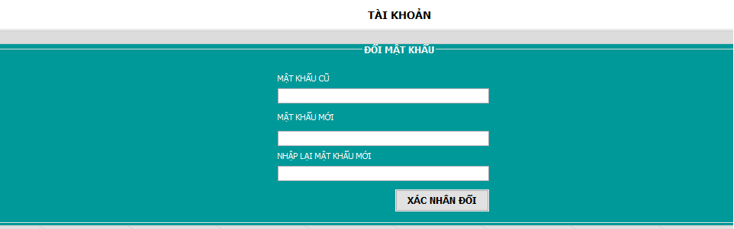

|  |  |  |
| --- | --- | --- |
| stt | Tên | Loại |
|  | btn_XacNhan | JButton |
|  | jLabel1 | JLabel |
|  | jLabel2 | JLabel |
|  | jLabel3 | JLabel |
|  | jLabel4 | JLabel |
|  | jPanel1 | JPanel |
|  | panel_Content | JPanel |
|  | pwd_Cu | JPasswordField |
|  | pwd_Moi | JPasswordField |
|  | pwd_NhapLai | JPasswordField |